

**Department of Artificial Intelligence**

**College of Computer Science and Information Technology**

**Due Date: Friday September 8, 2024 @ 11:59 PM \***

**Late Submissions:**

Q: Can I skip the lab and submit the solution?

You will receive a mark of **zero** if you do not attend the lab, even if you complete the exercise. Attending the labs is compulsory for evaluation. If you have a justified excuse, you may receive a partial mark depending on the circumstances. See the next question for information on late submissions.

**Q:** If I submit it at 12:00am, you’ll still mark it, right?

**A:** 11:59pm and earlier is on time. Anything after 11:59pm is late. Anything late will **NOT** be probably marked. If I find you have a legitimate cause, you will be graded according to the following rules (24 hours after deadline à assignment is marked out of 75% only, 48 hours after deadline à assignment is marked out of 50% only, 74 hours after deadline à assignment is marked out of 25% only).

Task 1

1. Display a cropped color image of the model space shuttle in the image.

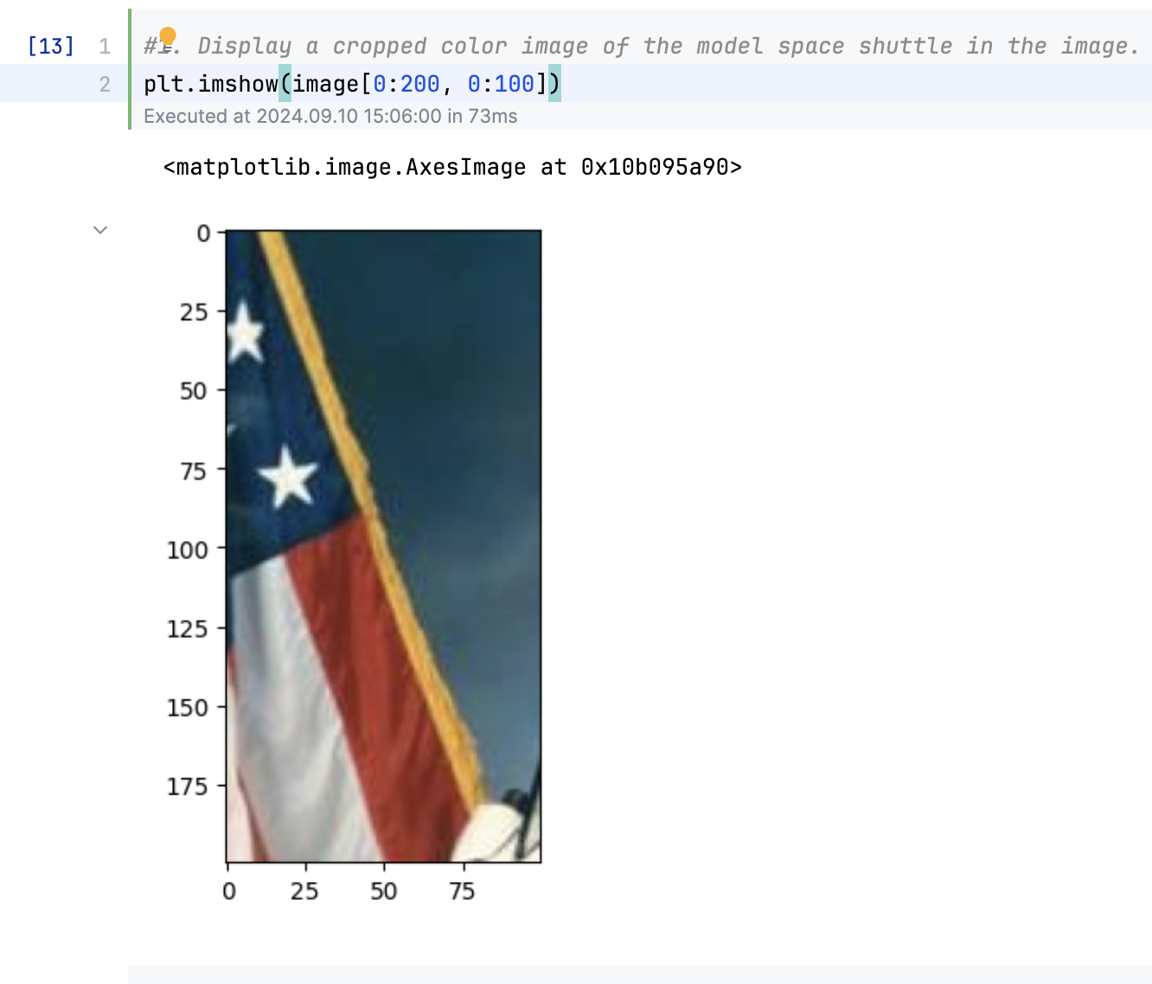

1. Display each color channel of image [0:200, 0:100] in grayscale.

1. Which channel is red? 0
2. Which channel is blue? 1
3. Which channel is green? 2

[Extra challenge] Create a new astronaut image where:

1. all perfectly white (r,g,b=255) pixels have been converted to red (r=255; g,b=0)

1. all perfectly black (r,g,b=0) pixels have been converted to blue (r,g=0; b=255)

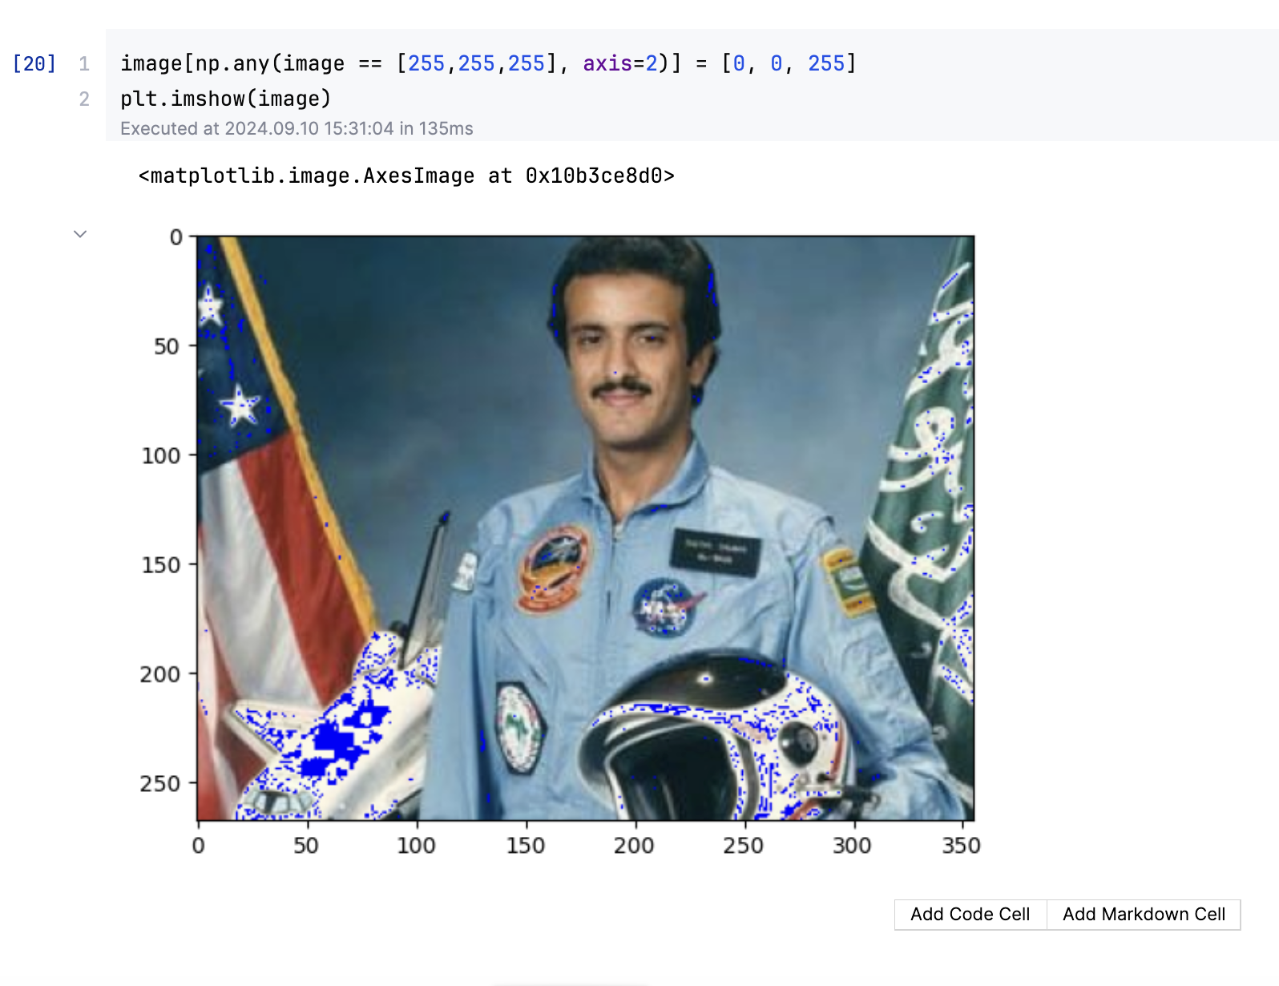

Task 2

**Complete your progress in the first lab.**

Return to the second task in the lab 1, and try altering Image Brightness using skimage

Hint: use the adjust_gamma function in skimage

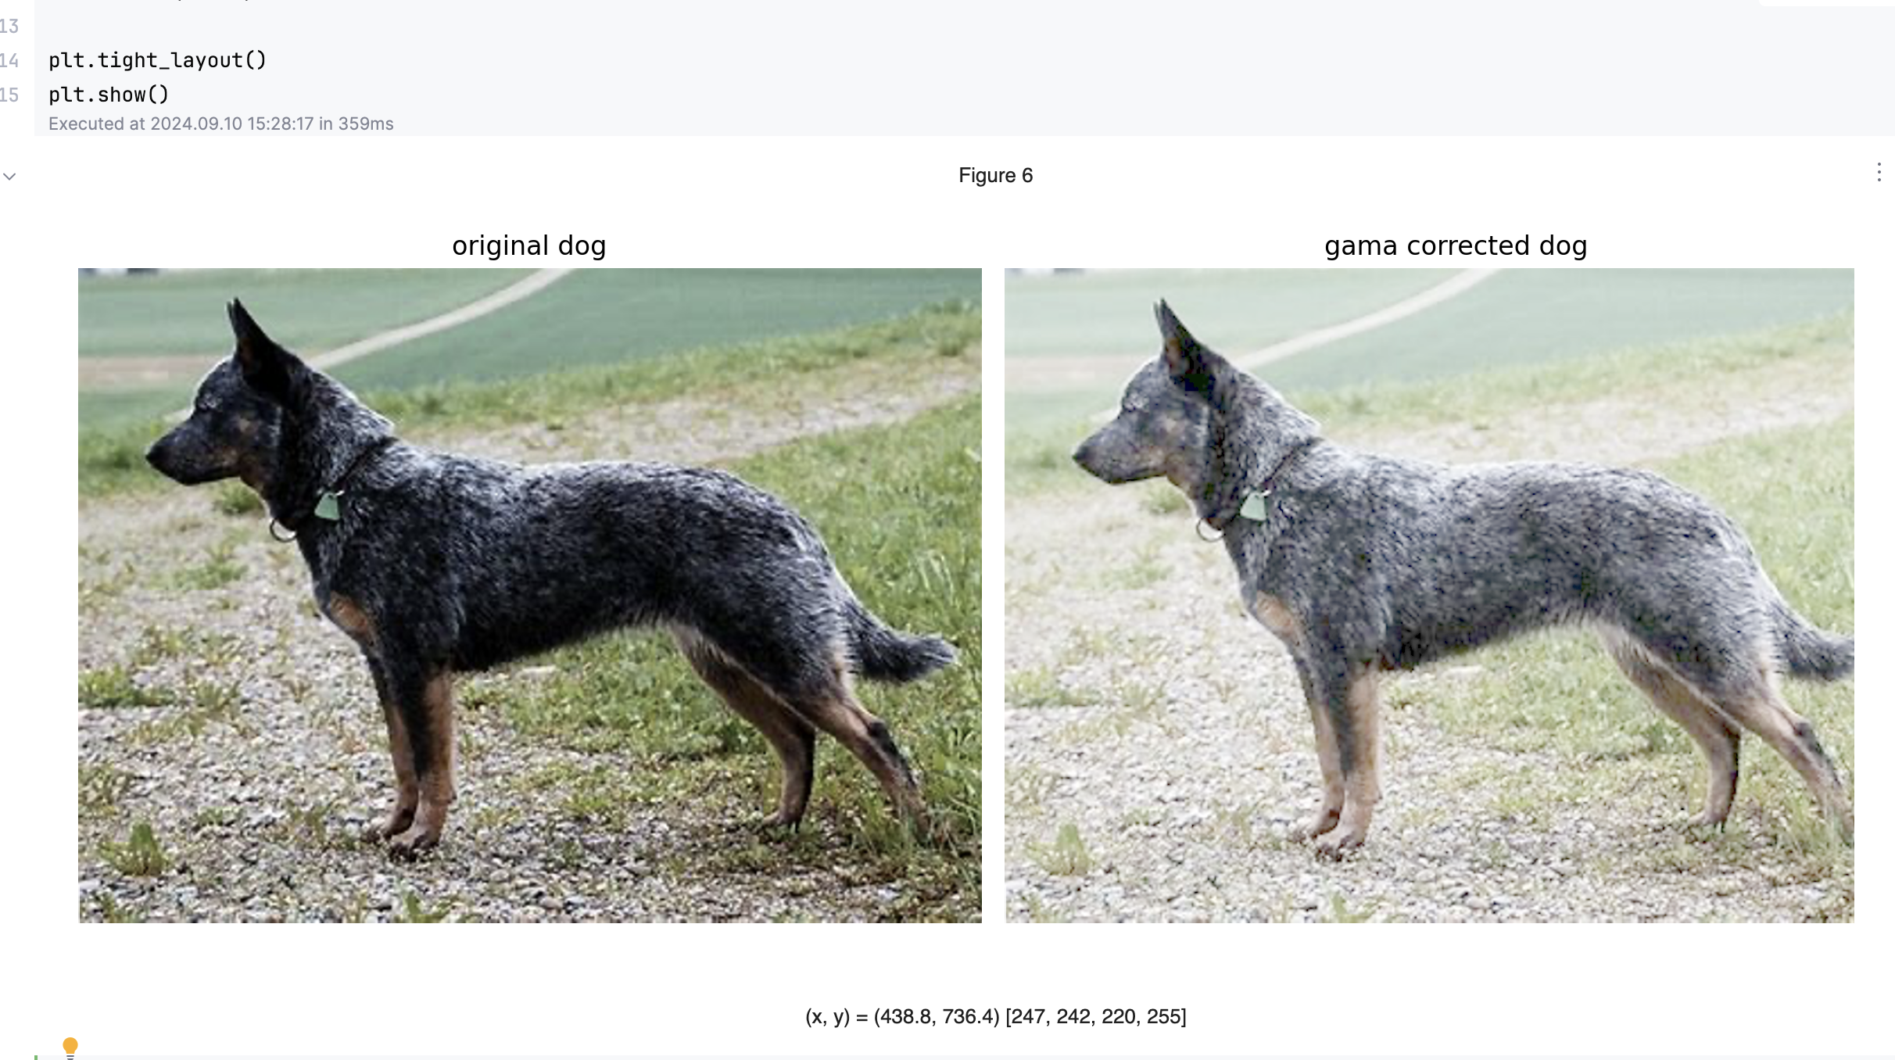

**Assessment**

1. Each student will show all the above parts running as demo to the Lab Instructor **before leaving the lab.** Total marks for the lab is as follows

|  |  |
| --- | --- |
| Task 1 | Marks (demo + report) |
| 1 | 10 |
| 2 | 10 |
| Total | 20 |

1. Students will prepare a report in which they will submit the snapshots taken while they worked on each part. They will explain the figures to make sure that they understood what they did.

**Documentation**

In the first task I use skimage, numpy and matplotlib to play around with the image and also encounter an error that my image was in a weird color but it turns out that its from my environment themes,(had to change it from dark to light).

And in the second task,

I use exposure and io form skimage to play around with the brightness.